19.AIM:- **:** To draw UML diagrams for home service system using umbrello

COMPONENT DIAGRAM:

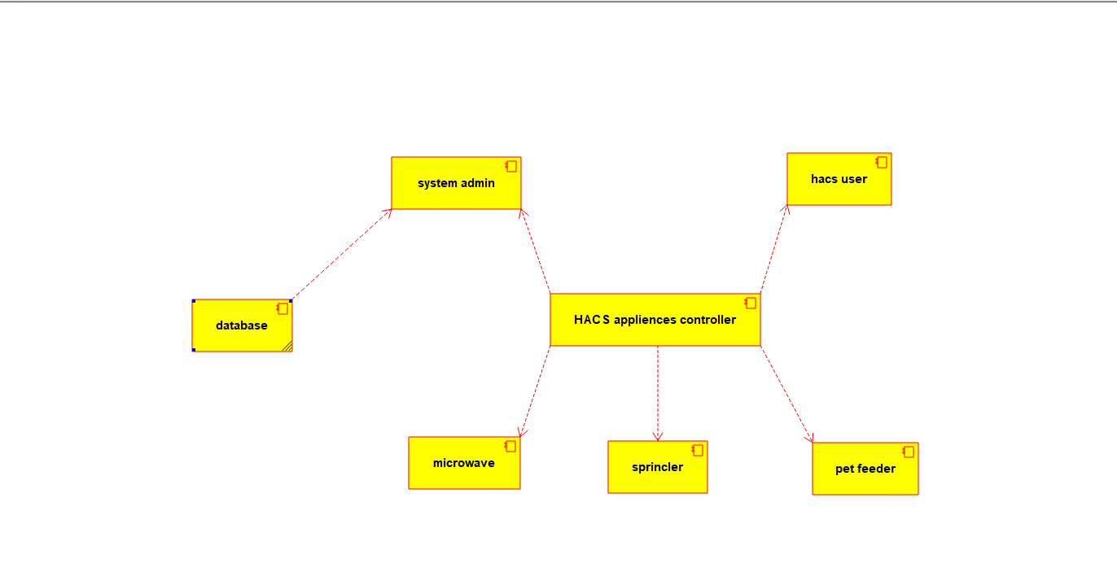

DEPLOYEMENT DIAGRAM:

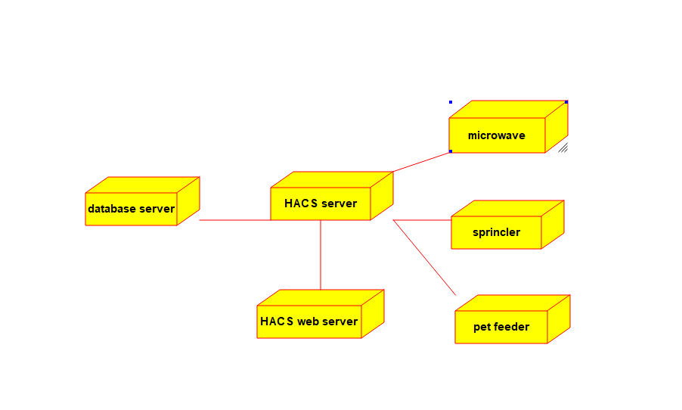

USE CASE DIAGRAM:

